

Technical Note:

Retrieve Photo Data from Instagram Using Instagram API

NIH Proposal for Food Environment

Project conducted by:

San Diego State University

5500 Campanile Drive

San Diego, CA 92182-4493

Report prepared by:

Yi-ting Chuang

**Department of Geography, San Diego State University**

Jan. 2015

# *Abstract*

This technical note introduces how to retrieve **food photos at Downtown** **San Diego** from Instagram by using Instagram API. This notes searched photos by setting location ids, based on longitude and latitude, and radius arguments.

# *Retrieve Food Photo at DOWNTOWN SAN DIEGO from Instagram Using Instagram API*

1. **What is Instagram?**

Instagram is an online mobile photo-sharing, video-sharing and social networking service that enables its users to take pictures and videos, and share them on a variety of social networking platforms, such as Facebook, Twitter, Tumblr and Flickr. A distinctive feature is that it confines photos to a square shape, similar to Kodak Instamatic and Polaroid images, in contrast to the 4:3 aspect ratio typically used by mobile device cameras. Users can also apply digital filters to their images. (<http://en.wikipedia.org/wiki/Instagram>)

1. **What is Instagram API?**

Registered users can search photos and related information according to different arguments by using Instagram API.

1. **Does the API need a key?**

Yes, before utilizing Instagram API, developers need to get an access key for calling methods of Instagram API. Go here: <http://instagram.com/developer/authentication/>.

1. **How to find photos for specific geographic areas? (e.g. Downtown San Diego)**

Go to “Location Endpoints” on Instagram website: <http://instagram.com/developer/endpoints/locations/>.

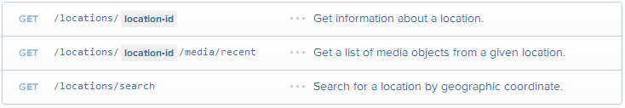

1. The third method can get a list of Instagram’s location ids by setting:

**Lng:** A valid longitude, in decimal format, for doing radial geo queries. **(e.g. -117.161)**

**Lat:** A valid latitude, in decimal format, for doing radial geo queries. **(e.g. 32.726)**

**Distance:** A valid radius used for geo queries, greater than zero and less than 5000m, for use with point-based geo queries. The default value is 1000m.

Note: Istagram API can only respond 20 location ids at a time. For getting more ids at a time, please utilize Facebook’s Graph API to get Facebook’s location ids and convert them into Instagram’s location ids.

1. The second method can search photos based on:

**Location_id:** Instagram location ids, which can be generated by using the third method.

**Other parameters:** <http://instagram.com/developer/endpoints/locations/>

1. **The following is an example of photos with “food” tag at Downtown San Diego (latitude: 32.715754; longitude: -117.161093) with 5 kilometers radius.**

**Instagram Location IDs:**

"data":[{"latitude":32.726005369,"id":"76449888","longitude":-117.16114532,"name":"Areta Crowell Center"},{"latitude":32.725929,"id":"252182784","longitude":-117.160861,"name":"Sharp Rees-Stealy Medical Centers"},{"latitude":32.726120597,"id":"254994208","longitude":-117.161077997,"name":"Mission Bay Park"},{"latitude":32.725788399,"id":"14535462","longitude":-117.160915565,"name":"Hawthorn and 4th"},{"latitude":32.726098621,"id":"451226492","longitude":-117.161246422,"name":"Sharp Rees Steely"},{"latitude":32.725939694,"id":"394497","longitude":-117.161286506,"name":"Sharp Rees-Stealy Downtown San Diego"},{"latitude":32.725735958,"id":"389099054","longitude":-117.161148371,"name":"Siti Medical Spa"},{"latitude":32.72626119,"id":"5824990","longitude":-117.16079247,"name":"Sharp Rees-Steely Urgent Care"},{"latitude":32.725645,"id":"14251612","longitude":-117.160856,

**Photo data:**

"data":[{"attribution":null,"tags":[],"type":"image","location":{"latitude":32.726120597,"name":"Mission Bay Park","longitude":-117.161077997,"id":254994208},"comments":{"count":7,"data":[{"created_time":"1416796151","text":"\u270c\ufe0f\ud83d\ude4c\ud83d\udcaa\ud83d\udd1d","from":{"username":"nnectoux","profile_picture":"https:\/\/igcdn-photos-b-a.akamaihd.net\/hphotos-ak-xpa1\/t51.2885-19\/10632376_630528803732193_1124873594_a.jpg","id":"34891169","full_name":"Nelson Nectoux"},"id":"860470941825098012"},{"created_time":"1416805872","text":"\ud83d\udc4f\ud83d\udc4f\ud83d\udc4f","from":{"username":"fsabbatini","profile_picture":"https:\/\/igcdn-photos-e-a.akamaihd.net\/hphotos-ak-xpf1\/t51.2885-19\/10693517_730206550394612_1811208857_a.jpg","id":"22278664","full_name":"Freddy Sabbatini"},"id":"860552490226540560"},{"created_time":"1416807791","text":"@nnectoux amazinggg!! Foi demais hoje, energia mega positiva!","from":{"username":"carlamariazinha","profile_picture":"https:\/\/igcdn-photos-c-a.akamaihd.net\/hphotos-ak-xpa1\/t51.2885-19\/10729199_1493937554215498_1974034382_a.jpg","id":"30615503","full_name":"Carla Maria"},"id":"860568590456709165"},{"created_time":"1416807824","text":"@fsabbatini at\u00e9 muito breve, sofri mas foi demais!!",

**Final outputs:**

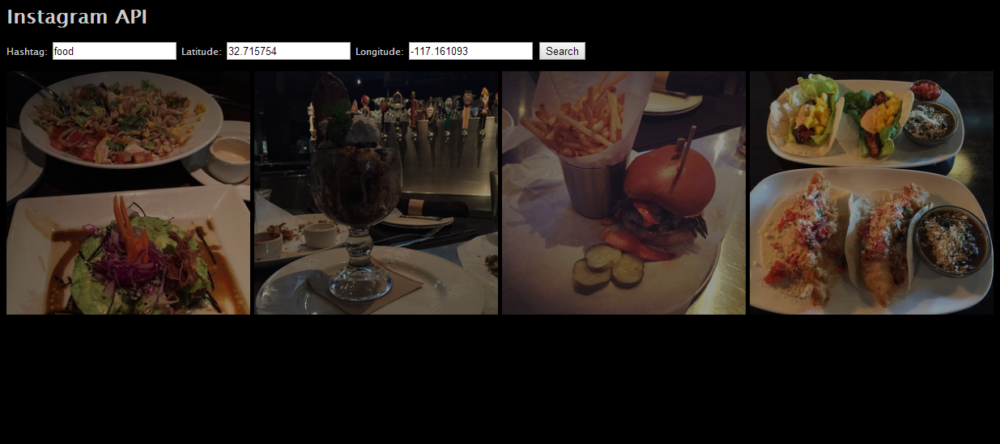

**Limitation**:

A limitation of using Istagram API to search location ids is that it only responds 20 location ids at a time. If you want to get more location ids at once, you can utilize Graph API by Facebook to get a list of facebook_places_ids (500 data) and convert it into Instagram location ids by using “locations/search?facebook_places_id” method. You can get 500 Instagram location ids instead of 20.